Practical No:= 1

Recursive :
def fibonacci_iterative(n):
series = []
a, b = 0, 1
for _ in range(n):
series.append(a)
a, b = b, a + b
return series
n = int(input("Enter the number of Fibonacci numbers to generate (iterative): "))
fib_series = fibonacci_iterative(n)
print(f"Fibonacci series (first {n} numbers) using iterative method:")
print(fib_series)

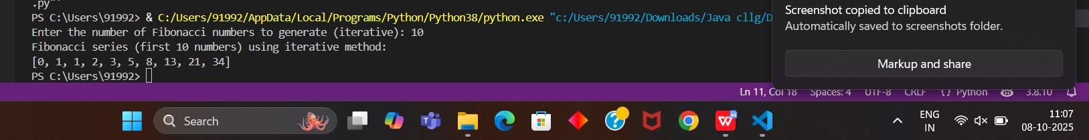

Non-Recursive:
def fibonacci_recursive(n):
if n <= 0:
return 0
elif n == 1:
return 1
else:
return fibonacci_recursive(n-1) + fibonacci_recursive(n-2)
num = int(input("Enter the number of terms for Fibonacci series (recursive): "))
print("Fibonacci series (recursive):")
for i in range(num):
print(fibonacci_recursive(i), end=' ')
print()

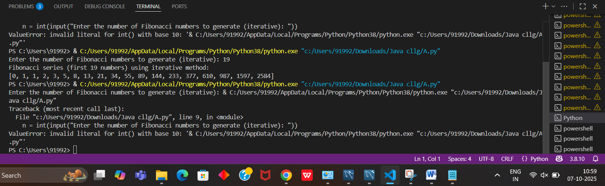

Practical No:= 2

import heapq
class Node:
def __init__(self, freq, char, left=None, right=None):
self.freq = freq
self.char = char
self.left = left
self.right = right

def __lt__(self, other):
return self.freq < other.freq

def build_huffman_tree(chars, freqs):
heap = [Node(freqs[i], chars[i]) for i in range(len(chars))]
heapq.heapify(heap)

while len(heap) > 1:
left = heapq.heappop(heap)
right = heapq.heappop(heap)
merged = Node(left.freq + right.freq, '-', left, right)
heapq.heappush(heap, merged)

return heap[0]

def print_codes(node, code=""):
if node is None:
return
if node.left is None and node.right is None:
print(f"{node.char} -> {code}")
return
print_codes(node.left, code + "0")
print_codes(node.right, code + "1")

def main():
chars = list(input("Enter characters (no spaces): "))
freqs = list(map(int, input("Enter frequencies (space-separated): ").split()))

if len(chars) != len(freqs):
print("Mismatch between characters and frequencies!")
return

root = build_huffman_tree(chars, freqs)
print("\nHuffman Codes:")
print_codes(root)

if __name__ == "__main__":
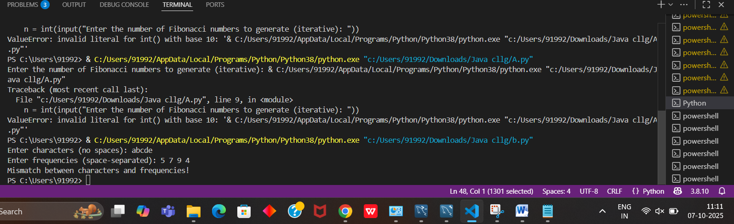
Practical No:= 3
def knapsack(weights, values, capacity):
n = len(values)
dp = [[0 for _ in range(capacity + 1)] for _ in range(n + 1)]

for i in range(1, n + 1):
for w in range(1, capacity + 1):
if weights[i - 1] <= w:
dp[i][w] = max(
values[i - 1] + dp[i - 1][w - weights[i - 1]],
dp[i - 1][w]
)
else:
dp[i][w] = dp[i - 1][w]

return dp[n][capacity]

def main():
values_input = input("Enter values of items (space-separated): ")
values = list(map(int, values_input.strip().split()))

weights_input = input("Enter weights of items (space-separated): ")
weights = list(map(int, weights_input.strip().split()))

if len(values) != len(weights):
print("Error: Number of values and weights must match.")
return

capacity = int(input("Enter knapsack capacity: "))
max_profit = knapsack(weights, values, capacity)
print(f"\nMaximum profit that can be achieved: {max_profit}")

if __name__ == "__main__":
main()

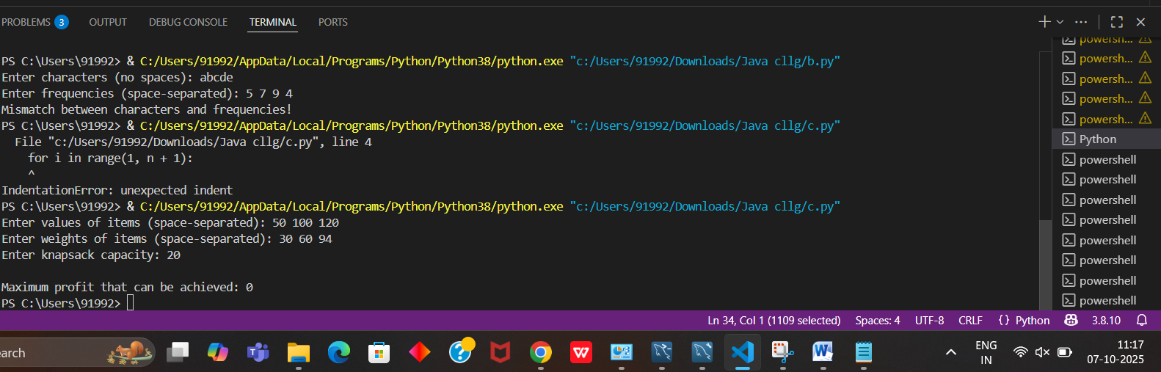

Practical No:=4
def is_safe(board, row, col, n):
# Check same column
for i in range(row):
if board[i][col] == 'Q':
return False

# Check upper-left diagonal
i, j = row - 1, col - 1
while i >= 0 and j >= 0:
if board[i][j] == 'Q':
return False
i -= 1
j -= 1

# Check upper-right diagonal
i, j = row - 1, col + 1
while i >= 0 and j < n:
if board[i][j] == 'Q':
return False
i -= 1
j += 1

return True

def print_board(board):
for row in board:
print(" ".join(row))
print()

def solve_n_queens(board, row, n):
if row == n:
print_board(board)
return

for col in range(n):
if is_safe(board, row, col, n):
board[row][col] = 'Q'
solve_n_queens(board, row + 1, n)
board[row][col] = '-' # Backtrack

def main():
N = 8 # You can change this to any N
board = [['-' for _ in range(N)] for _ in range(N)]
solve_n_queens(board, 0, N)

if __name__ == "__main__":
main()

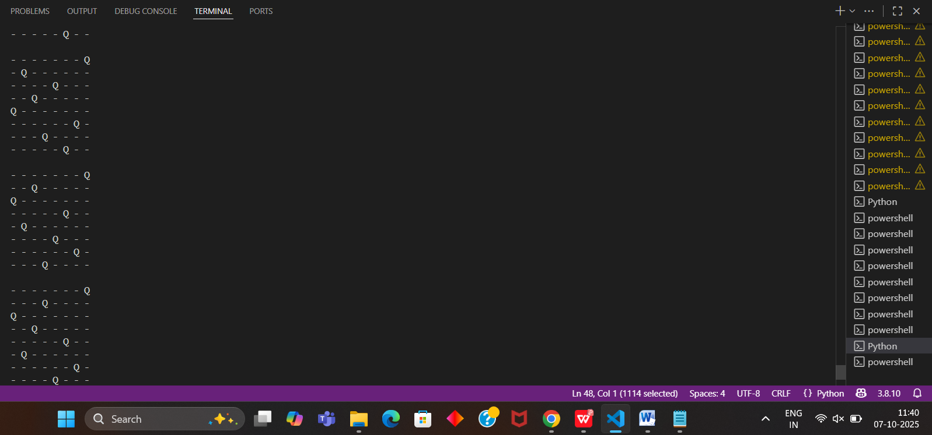

Practical No:= 5

import random
import time

# Deterministic Quick Sort
def quick_sort_det(arr):
if len(arr) <= 1:
return arr
pivot = arr[0] # always pick the first element
left = [x for x in arr[1:] if x <= pivot]
right = [x for x in arr[1:] if x > pivot]
return quick_sort_det(left) + [pivot] + quick_sort_det(right)

# Randomized Quick Sort
def quick_sort_rand(arr):
if len(arr) <= 1:
return arr
pivot = random.choice(arr) # pick a random pivot
# Create new lists without modifying original `arr`
left = [x for x in arr if x < pivot]
middle = [x for x in arr if x == pivot]
right = [x for x in arr if x > pivot]
return quick_sort_rand(left) + middle + quick_sort_rand(right)

# Generate random array
data = [random.randint(1, 10000) for _ in range(1000)]

# Time deterministic quick sort
start = time.time()
quick_sort_det(data.copy())
print("Deterministic Quick Sort Time:", round(time.time() - start, 6), "sec")

# Time randomized quick sort
start = time.time()
quick_sort_rand(data.copy())
print("Randomized Quick Sort Time:", round(time.time() - start, 6), "sec")

